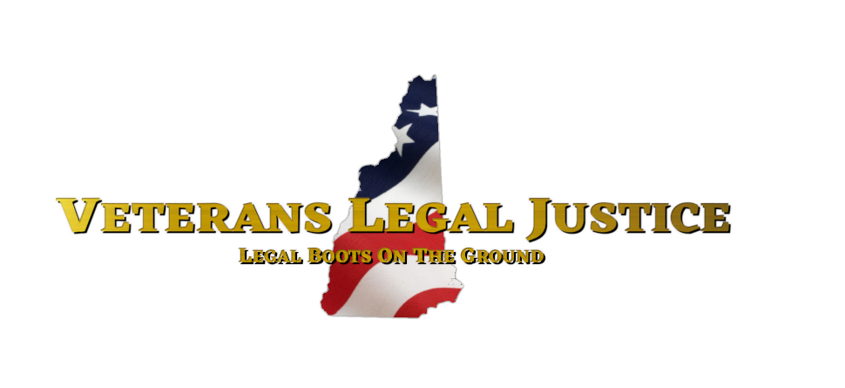
MISSION
The mission of Veterans Legal Justice (VLJ) is to ensure that veterans and service members in the State of New Hampshire receive the best possible legal representation at low or no cost. Through our network of dedicated attorneys, we provide excellent legal assistance for our clients. We at VLJ extend a welcoming hand to those who have put on the uniform, regardless of discharge status.

VISION
A military community with access to affordable legal services that are responsive to the needs of veterans facing all types of legal challenges.

Call (603)-397-0650 for Intake Services
Visit vljnh.org for more information

Active since November 11, 2022

